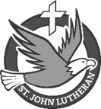
St. John News
March 29, 2026
St. John Evangelical Lutheran Church & School School founded 1846
North Tonawanda, New York Church founded 1853
St. John is a Christian community called to worship and sent to serve, welcoming all to walk with Christ and grow in faith.

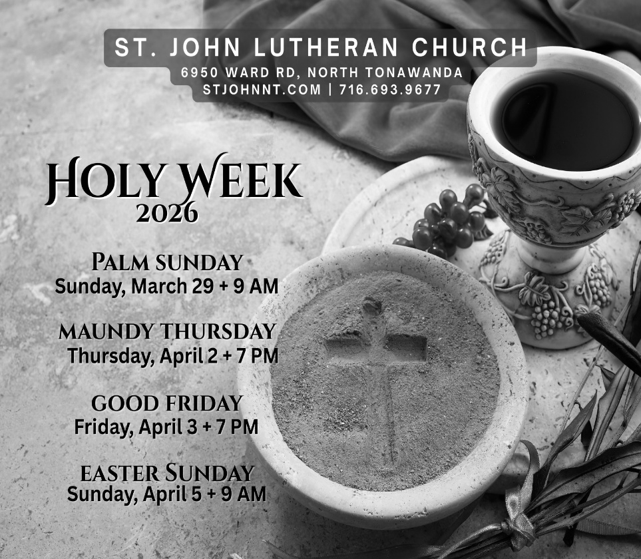

Sunday, March 29
Palm Sunday
- Choir practice – 8:00 AM
- Worship – 9:00 AM
- Education Hour – 10:15 AM
Wednesday, April 1
- NO Worship
Thursday, April 2
Maundy Thursday
Grandparents’ Day
- School Chapel – 9:30 AM
- Worship w/Communion – 7:00 PM
- Choir Practice – 8:00 PM
Friday, April 3
Good Friday
- Worship – 7:00 PM
- Handbell Rehearsal – 8:00 PM
Saturday, April 4
- NO Men’s Group
Sunday, April 5
Easter Sunday
- Worship w/Communion – 9:00
- NO Education Hour
Tuesday, April 7
- Elders’ Meeting – 6:30 AM
Wednesday, April 8
- Worship w/Communion – 7:00 PM
Saturday, April 11
- Men’s Group – 7:00 AM
- Mowers’ Meeting – 10:00 AM

Thank you to everyone who made the Seder Meal possible. The preparation, service, and clean-up served to bring people to see Christ in the old Passover meal and traditions.


Thrivent Choice Dollars If you have any Choice Dollars left for 2025, your deadline to direct them to St. John is March 31st.
Please take a few minutes to log in to your Thrivent account or call Thrivent to designate your Choice Dollars to support our church and school. It’s a simple way to turn benefits you already have into a blessing for our students, families, and ministry.
At the Church

Mowers Needed
Now that spring is here and the cold and snowy winter is behind us, our thoughts turn to the outdoors. Our properties here at the St John church, school, and cemetery are large - almost 10 acres. A lot of work is required to maintain our property and do it in a way that shows the community the pride we have in our facilities. Volunteers do most of the work, but we can always use more. So, if you like being outdoors, the smell of a freshly mowed lawn, the thrill of operating power equipment, want to further improve the appearance of your church, school, and cemetery, or just want some camaraderie, consider volunteering. ALL adults are welcome, and schedule challenges can be met. If you would like to help or want more details, please contact Jeff Manning at 716-754-9583.

A/V Help Wanted- No experience necessary
We are looking for additional help on our audio/visual team for Sunday mornings. Training is available! Want to dip your toe in, or want to be a young helper? We’d love to have an assistant team do some of the more beginner elements. For more information, or to receive training, contact Pastor Mike at pastor@stjohnnt.com.
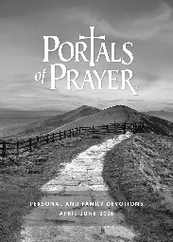
The second quarter Portals of Prayer are now out and available to pick up, on the Information Center table or in the glass entrance.
You can also find the new LCMS World Relief Sharing Newsletter and Concordia St. Catherines’ second quarter newsletter at the Information Center table.

Cemetery decorations, flower containers, etc…
To facilitate spring cleanup, the cemetery maintenance crew requests that all winter, Christmas wreaths/decorations should be removed by April 15. The cemetery guidelines are available at the church office.


A Special Thank You to our Wednesday worship service volunteers, who make every week run more smoothly.
Usher/acolyte: Mike Scive
Greeter: Christie Scive
Elder: Bob Borgtede
Thank you for your service!

Serving April 5th:
Elders for April: Terry Haseley & John Rosebrock Acolyte: Lucy Schultz
Reader: Dennis Kelly A/V: Brayden Redding
Children’s Message: Pastor Mike
Counting: Peggy Meyer, Mike Scive, Mike Scive II, Matt Scive, Sharon Muir
Altar for April: Linda Sonnen, Annie Kelly, Donna Carr
Greeters for April: Frank & Kathy Wendt
Hospitality: Peggy & Doug Meyer, Lorrie Weir Suzette Drenko, Sue Kenyon
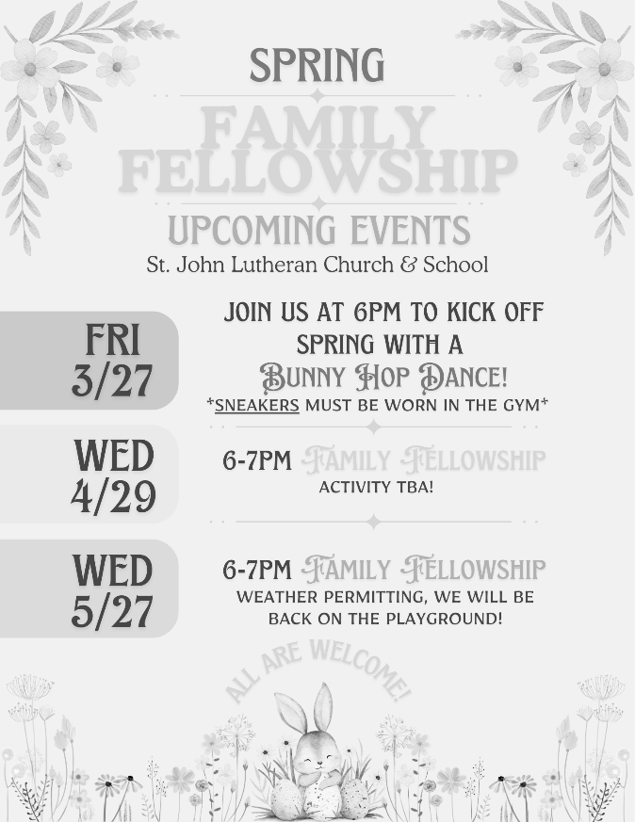
AT THE SCHOOL
Completed
  Nurturing children academically and spiritually toward a life of witness and service in Christ. | Greetings St. John families,  Happy Palm Sunday! Jesus in peace and humility enters Jerusalem to a crowd of people shouting "Hosanna, Hallelujah!" This is how Zechariah prophesied about Jesus' triumphal entry, "Rejoice greatly, O daughter of Zion! Shout aloud O daughter of Jerusalem! Behold your king is coming to you; righteous and having salvation is He, humble and mounted on a donkey, on a colt, the foal of a donkey." This is such a special week ahead of us where our Savior shows us just how loved we are.  Did you know...  - St. John hosted our first Alumni Basketball event. Over 35 alumni participants are expected to play on their HOME court this Saturday afternoon.  - St. John will be hosting Grandparents Day on Thursday, April 2nd. This annual event is a special day for our school community.  - Our Chapel mission for the next few weeks is going toward the LCMS initiative called "Set Apart to Serve," encouraging youth and young men/women to consider church work.    - Please check the back table in the church Narthex for our annual Alumni News. It highlights some exciting things going on in our school ministry and includes a special message about my dad, Herb Meissner, and his years of service at St. John. If you would like this Newsletter mailed to you in future years, please reach out to office@stjohnnt.com with your home address and ask to be included in the Alumni News mailing in future years.  - Check out our school’s weekly school newsletter:  Katie Gundell  Principal
IN OUR PRAYERS
Please ask permission to publish prayers that are not for yourself.
Private prayers – pastormike@stjohnnt.com or 716-693-9677 option 7
Contact the church office: churchoffice@stjohnnt.com or phone: 716-693-9677 option 2
Short-Term Prayers– Items with a filled square are on their final week on the prayer list. Please use the back of your Connection Card or contact the church office if you would like to renew prayers or submit new requests.
- Stacey Vogel (worker at Potter’s Field) – Health concerns
- Laura Ciffa (wife of P.E. teacher, Sal) – Health concerns

- Donna Cornell – Recovering from surgery
- Ava Schultz: for my family and friends
- Karen Herman – Ongoing health issues
- Jeff Herman – Undergoing tests
- Eileen (Annie Kelly’s mom) – Ongoing health concerns
- Sandra Carr – Safe travel
- The Norris family at the sudden death of Bob’s brother
- Mother of Claire Newton – Cancer diagnosis

- St. John School: That the neighborhood around us find the light of Jesus, the quality education, and the strong community here.
- For adult children to return to the Church.
- For places of conflict, especially Iran and Ukraine
- For more unity in our homes, community, and nation
- That we might proclaim the Word of God to the lost, so they can see their need for a Savior and know Him
Long Term Prayers
Owen Arizmendi, George Barnett, Jason Barry, Frank Cornell, Doreen & Larry Damba, Carol Donner, Shelly Erwin, Emma Gauda, Paul Greinert, Rick Hamilton, Bev Harder, Elsbeth Kaus, Annie Kelly, Barb Manning, Dennis Martin, Donna Martin, Ken Musall, Doug Rich, Rosie Siegmann, Mary Schlegl, Jaycee Schmitz, Donald Schultz, Kim Snell, Matthew Wallace, Doris Wollaber
In the U.S. Military: David Hoppe, Stephen Marshall, Ben Bahr
The Bereavement Department at Niagara Hospice provides grief support groups in Lewiston, Sanborn, and North Tonawanda. Please see the posting on the bulletin board.
Please note:
- Short-Term prayers are kept on the prayer list for 4 weeks.
- Updated prayer requests will be considered renewed.
- If you would like your prayer request to be moved to the Long-Term Prayers, please contact the office.

